


LAB WEEK 8
  - SEP 2026 SEMESTER

‘AFFAN NAJIY BIN RUSDI
22010453
BACHELOR OF COMPUTER SCIENCE
MODELING AND SIMULATION
TEB2103

Contents
Exercises 3
Exercise 1 3
Exercise 2 4
Exercise 3 5
Exercise 4 6
Exercise 5 7

Exercises

Exercise 1
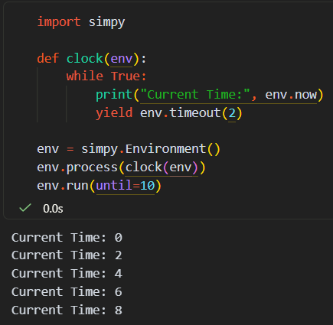

Explanation
Firstly, the clock from Step 4 was changed to yield `env.timeout(2)` instead of `env.timeout(1)`, so the process pauses for 2 time units after every print. SimPy skips t = 1, 3 and 5 completely, as the clock jumps straight to the next event. With `env.run(until=10)`, the clock printed 5 times at t = 0, 2, 4, 6 and 8. The time t = 10 is not printed, because the simulation stops right at 10, similar to a shop closing exactly at 10 pm.

Code
import simpy

def clock(env):
while True:
print("Current Time:", env.now)
yield env.timeout(2)

env = simpy.Environment()
env.process(clock(env))
env.run(until=10)

Exercise 2
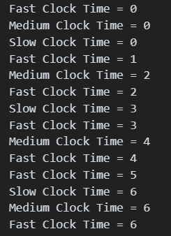

Explanation
Secondly, three processes were created from the same `clock()` function from Step 5, each with its own name and interval, and all three run together in one environment. Over 7 time units, the clocks ticked 7, 4 and 3 times. At t = 6, all three clocks tick at the same time, whereby SimPy runs them in the order they were scheduled. Hence, the Slow Clock prints first at t = 6, as it scheduled that tick earliest, at t = 3.

Code
import simpy

def clock(env, name, interval):
while True:
print(name, "Time =", env.now)
yield env.timeout(interval)

env = simpy.Environment()
env.process(clock(env, "Fast Clock", 1))
env.process(clock(env, "Medium Clock", 2))
env.process(clock(env, "Slow Clock", 3))
env.run(until=7)

Exercise 3
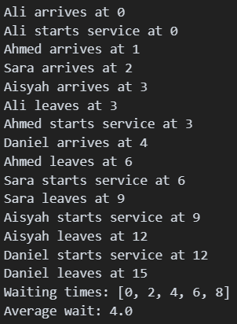

Explanation
Thirdly, the cashier example from Step 9 was extended to five customers, who arrive 1 time unit apart, while each service takes 3 time units. Since service is slower than arrivals, a queue builds up, much like a bank counter during lunch hour. `yield request` makes each customer wait until the cashier is free, and the waiting time is the start time minus the arrival time. As a result, Ali did not wait at all, while Daniel waited 8 time units, giving an average wait of 4.0.

Code
import simpy

waits = []

def customer(env, name, cashier, arrival):
yield env.timeout(arrival)
print(name, "arrives at", env.now)
with cashier.request() as request:
yield request
print(name, "starts service at", env.now)
waits.append(env.now - arrival)
yield env.timeout(3)
print(name, "leaves at", env.now)

env = simpy.Environment()
cashier = simpy.Resource(env, capacity=1)
env.process(customer(env, "Ali", cashier, 0))
env.process(customer(env, "Ahmed", cashier, 1))
env.process(customer(env, "Sara", cashier, 2))
env.process(customer(env, "Aisyah", cashier, 3))
env.process(customer(env, "Daniel", cashier, 4))
env.run()

print("Waiting times:", waits)
print("Average wait:", sum(waits) / len(waits))

Exercise 4
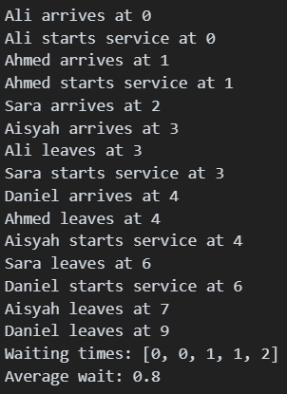

Explanation
Fourthly, the same five customers were simulated again, but with `capacity=2`, so two customers can be served at the same time. Ali and Ahmed went straight to a cashier, while the others only waited 1 or 2 time units. Hence, the average wait dropped from 4.0 to 0.8, and the last customer left at t = 9 instead of t = 15. The only change in the code is the capacity value, as SimPy handles the queue on its own.

Code
import simpy

waits = []

def customer(env, name, cashier, arrival):
yield env.timeout(arrival)
print(name, "arrives at", env.now)
with cashier.request() as request:
yield request
print(name, "starts service at", env.now)
waits.append(env.now - arrival)
yield env.timeout(3)
print(name, "leaves at", env.now)

env = simpy.Environment()
cashier = simpy.Resource(env, capacity=2) # 2 cashiers instead of 1
env.process(customer(env, "Ali", cashier, 0))
env.process(customer(env, "Ahmed", cashier, 1))
env.process(customer(env, "Sara", cashier, 2))
env.process(customer(env, "Aisyah", cashier, 3))
env.process(customer(env, "Daniel", cashier, 4))
env.run()

print("Waiting times:", waits)
print("Average wait:", sum(waits) / len(waits))

Exercise 5
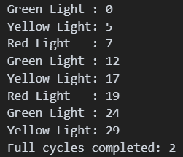

Explanation
Lastly, the traffic light from Step 10 was run with `env.run(until=30)`, where green lasts 5 time units, yellow 2 and red 5, so one cycle takes 12 time units. A counter was added to count each completed cycle. Within 30 time units, the light completed 2 full cycles, and the third cycle was cut off at yellow when the simulation stopped. This is similar to a traffic light at a junction, which keeps repeating until it is switched off.

Code
import simpy

cycles = 0

def traffic_light(env):
global cycles
while True:
print("Green Light :", env.now)
yield env.timeout(5)
print("Yellow Light:", env.now)
yield env.timeout(2)
print("Red Light :", env.now)
yield env.timeout(5)
cycles += 1

env = simpy.Environment()
env.process(traffic_light(env))
env.run(until=30)

print("Full cycles completed:", cycles)



